Page Field – Premier Business and General Aviation Airport
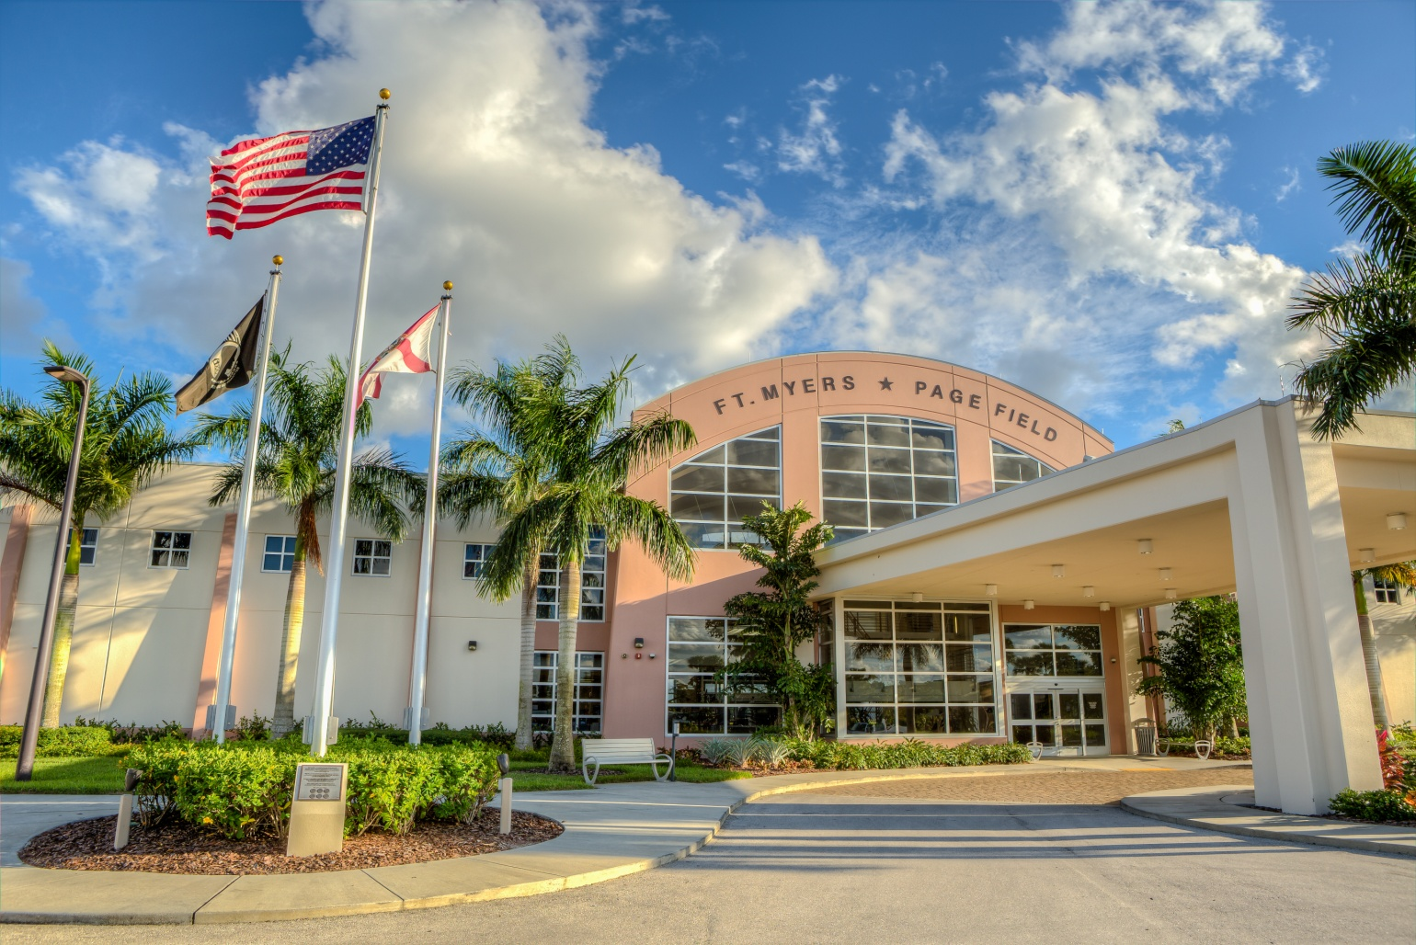

During World War II, Page Field was an important advanced fighter training base
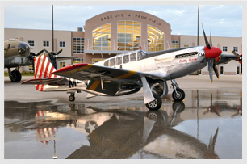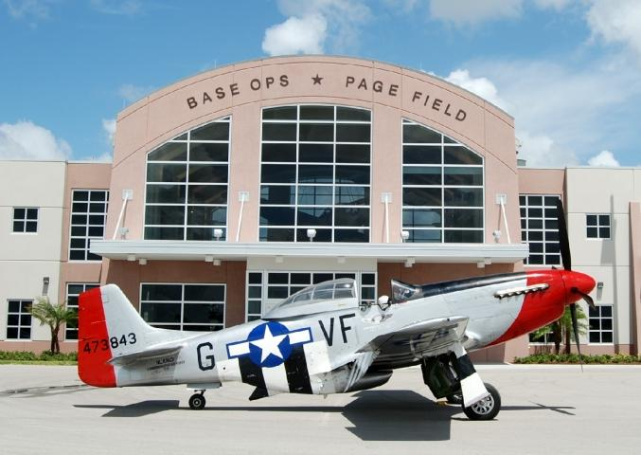

Bell Tower Shops
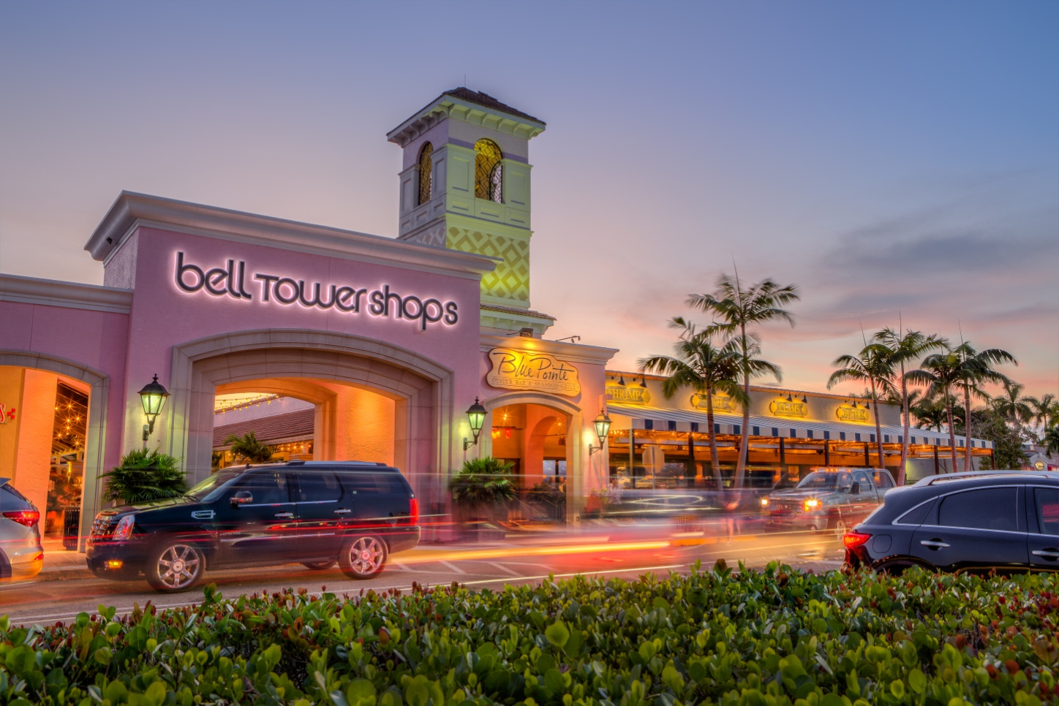

Chico’s World Headquarters
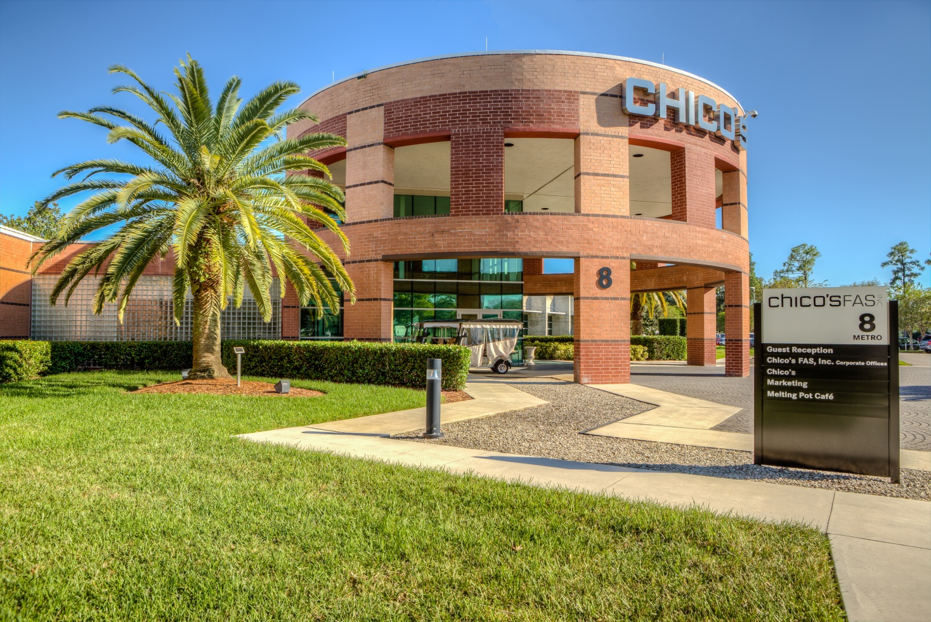
Chico’s World Headquarters Campus

First Family Insurance
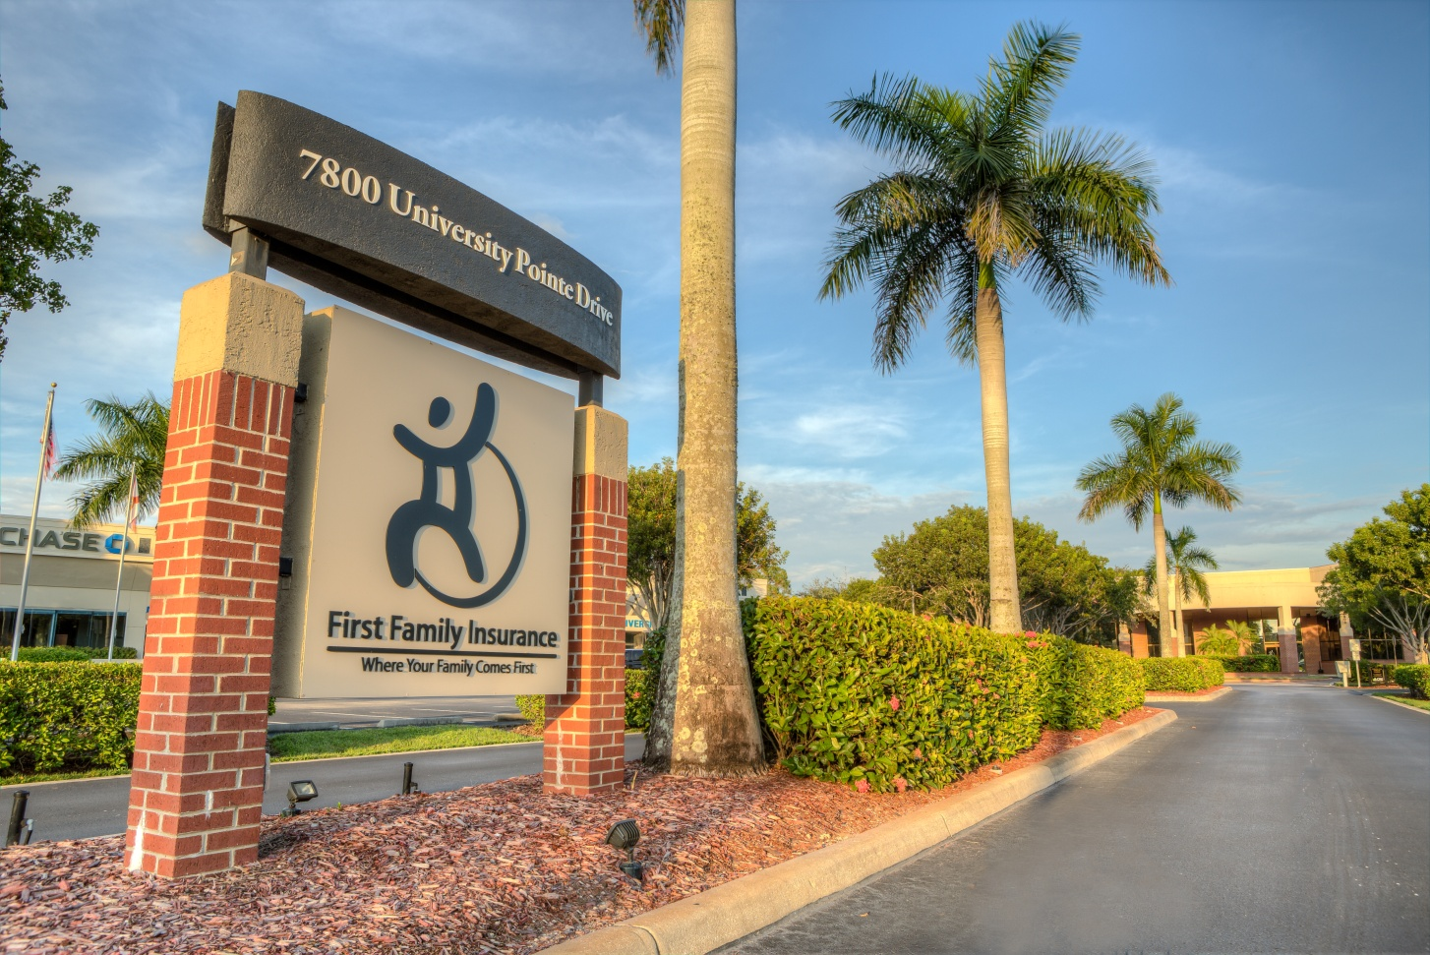
R+L Global Logistics

San Carlos Park Arch
CenturyLink Sports Complex – Home to Hammond Stadium
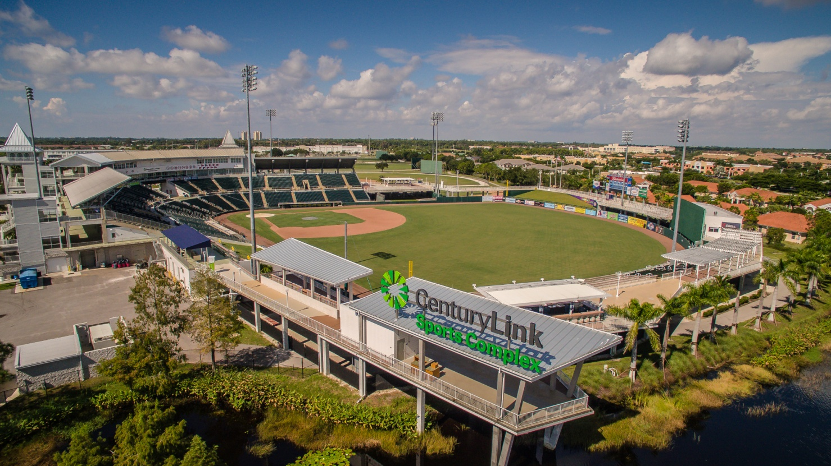

Hammond Stadium – Spring Training Home of the Minnesota Twins and Home to the Fort Myers Miracle
