**Downtown Fort Myers**

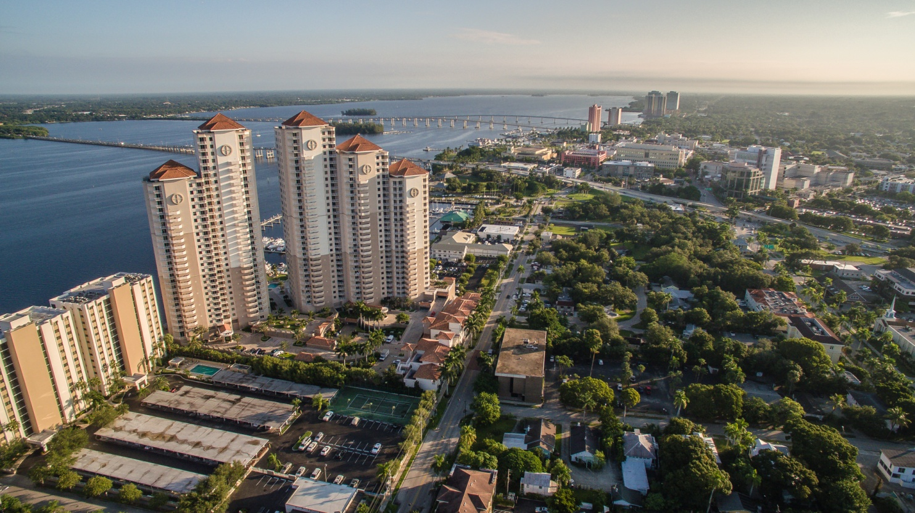

**Harborside Event Center**

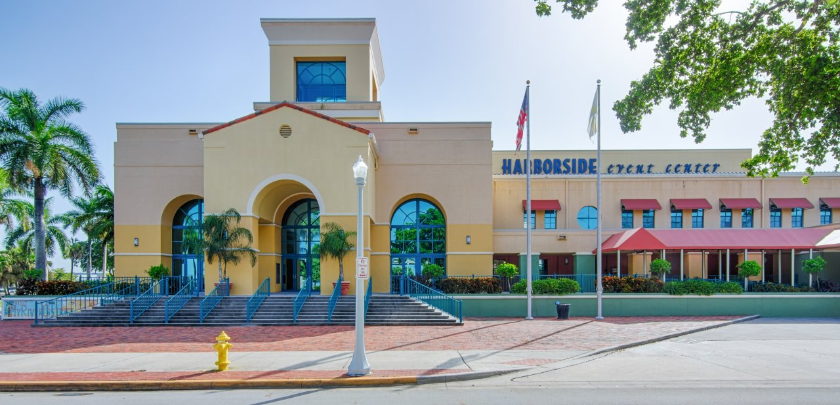

**Sidney & Berne Davis Art Center**

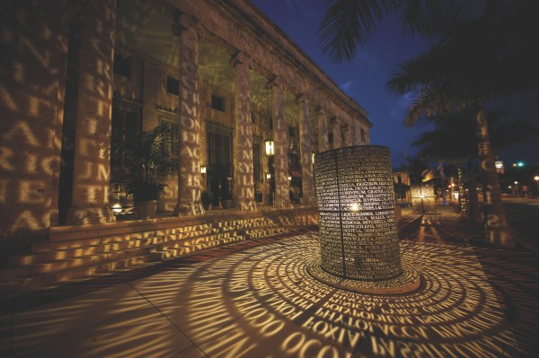

**Fort Myers Art Galleries**

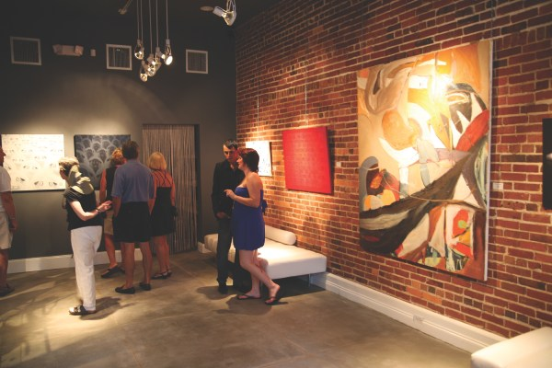

**View of Downtown from the Edison & Ford Winter Estates along McGregror Blvd**

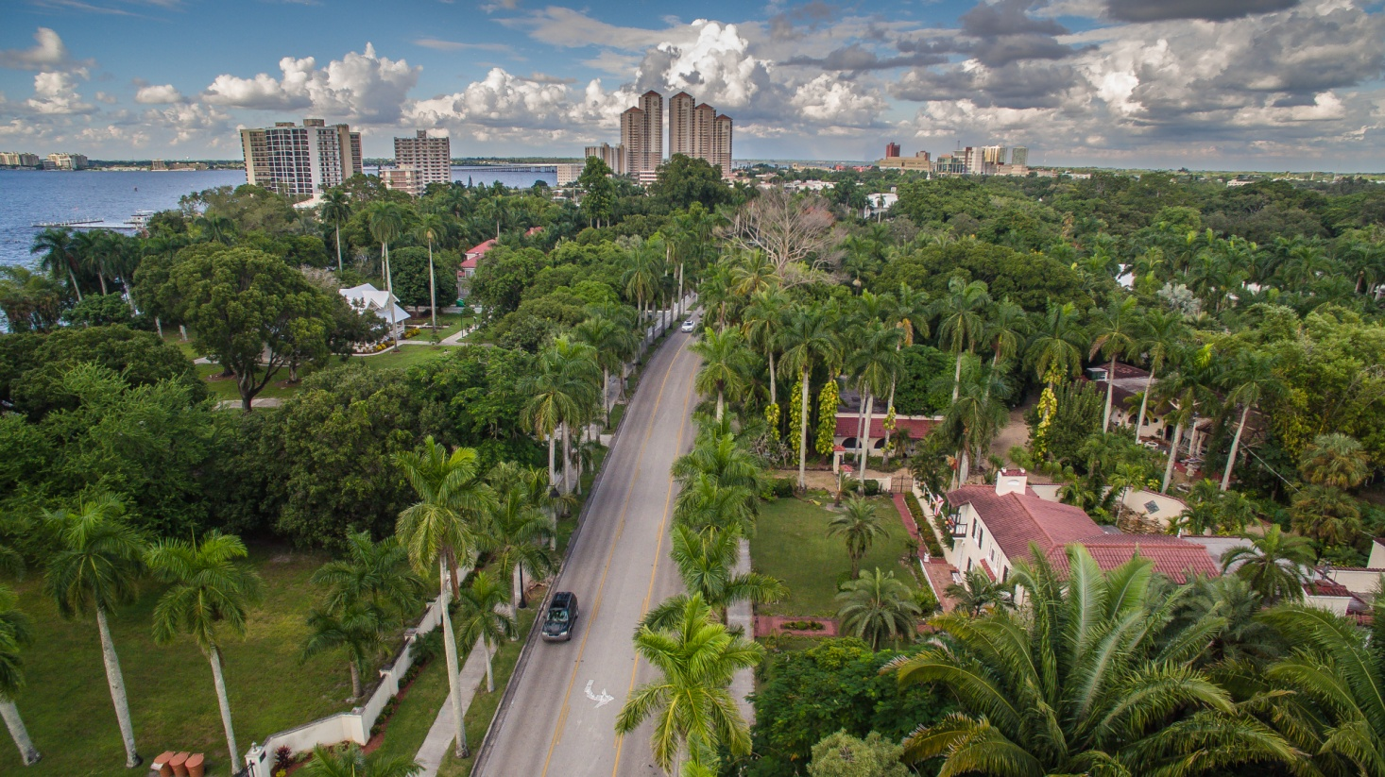

**Edison & Ford Winter Estates – home to the 3rd largest banyon tree in the world**

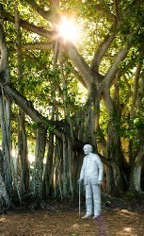 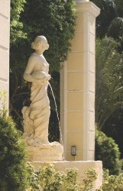

**21st Century Oncology Corporate Headquarters**

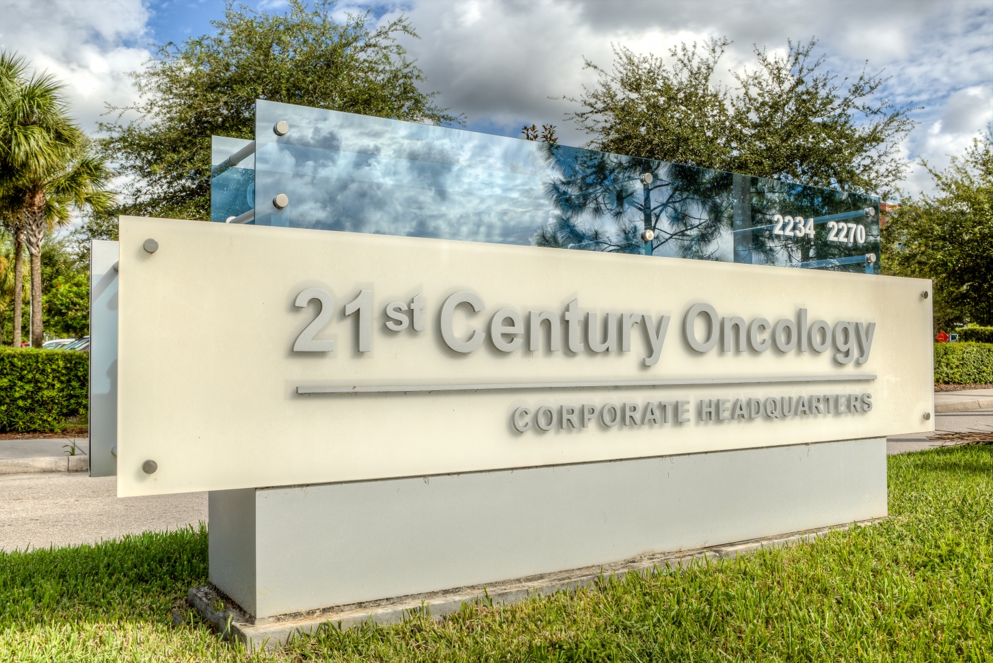

**LeeSar Regional Service Center**

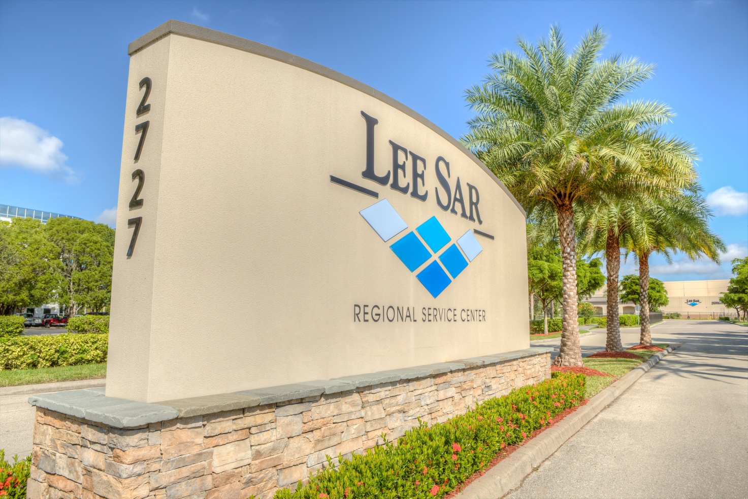

**Edison Mall**

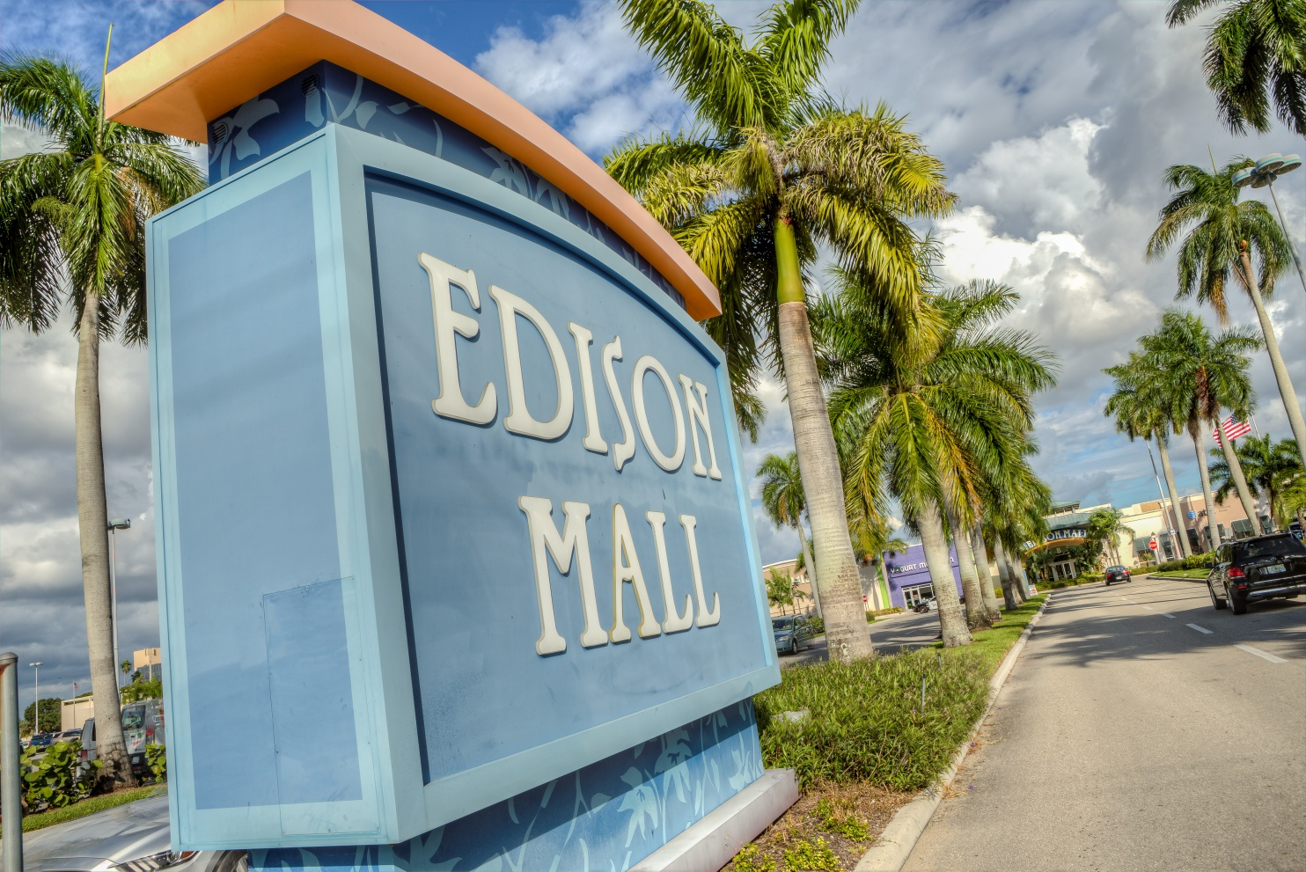

**Edison Park Elementary School**

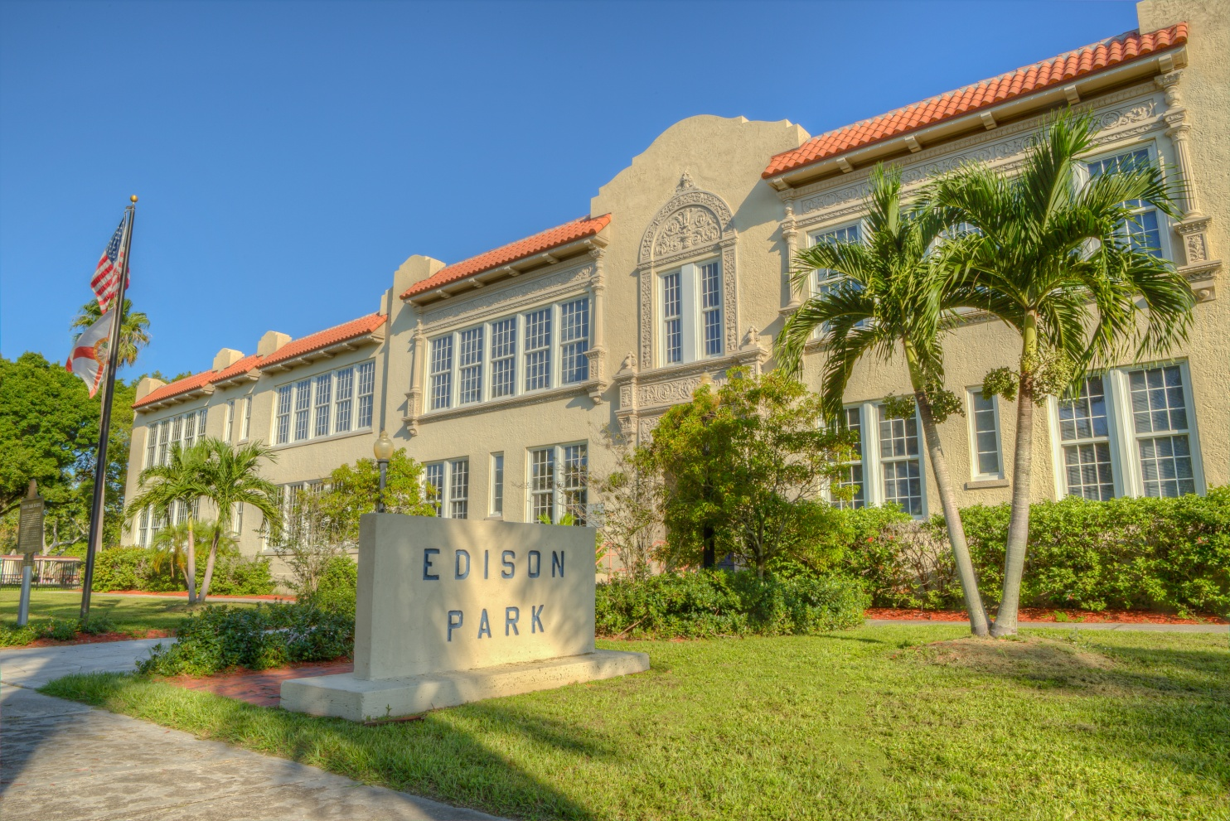

**Fort Myers High School**

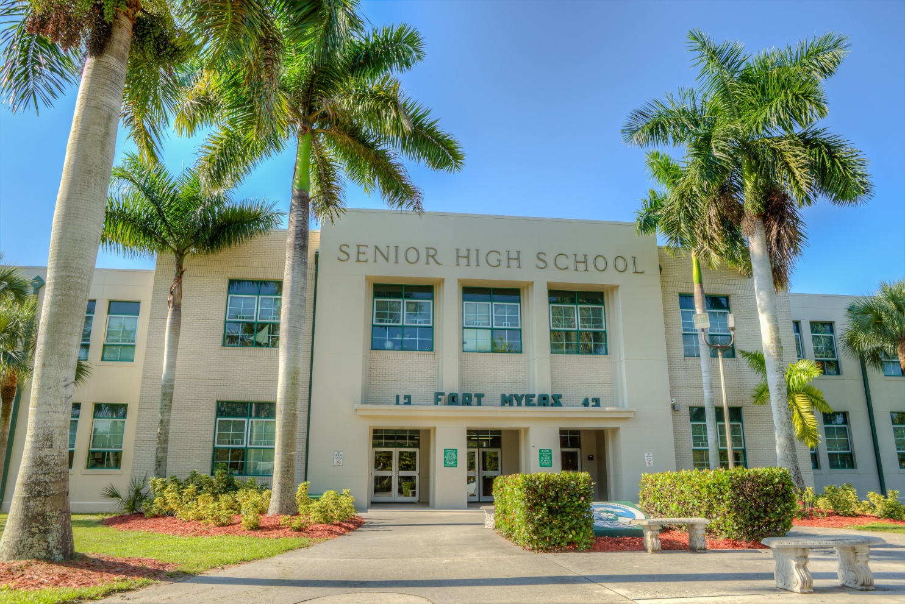

**Hodges University**

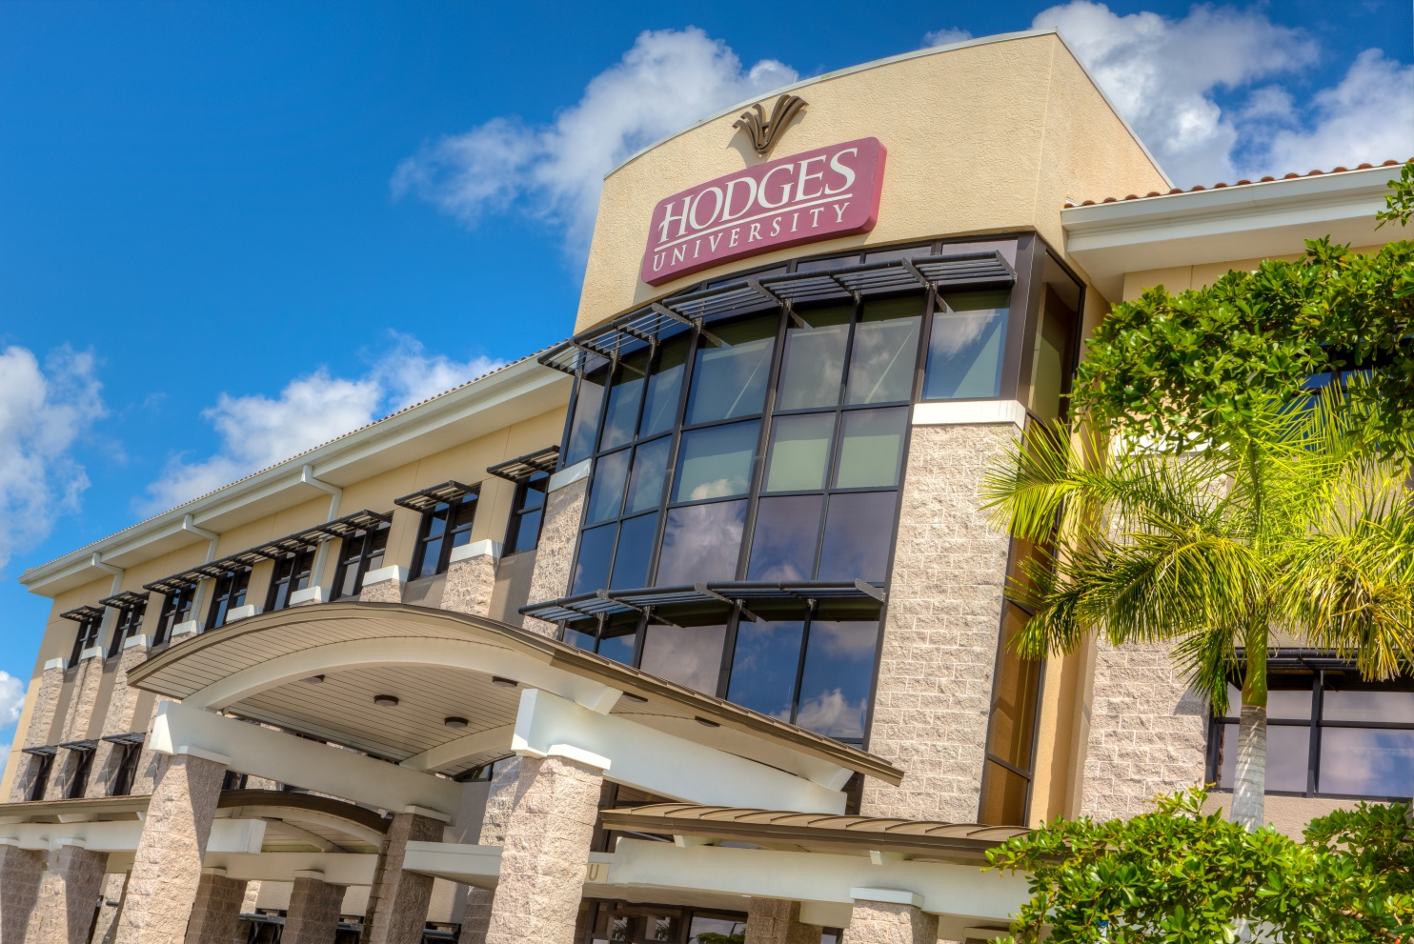

**Keiser University**

