**Bonita Beach**

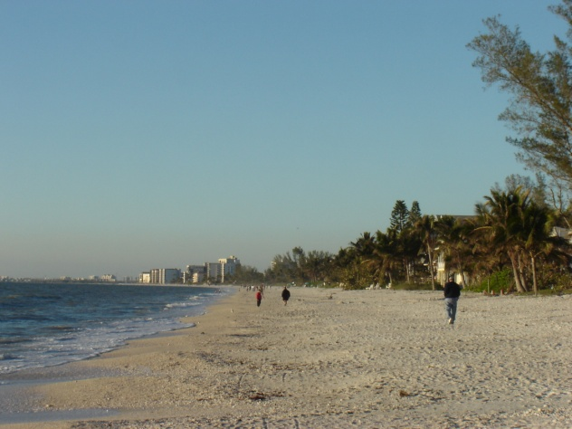

**Lovers Key State Park**

**loverskey-aerial.tif**

**Lovers Key State Park**

**loverskey-boardwalk.tif**

**Everglades Wonder Gardens**

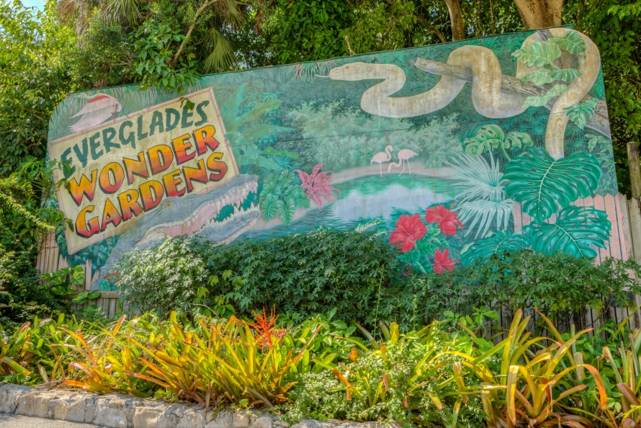

**Hertz Equipment Rental**

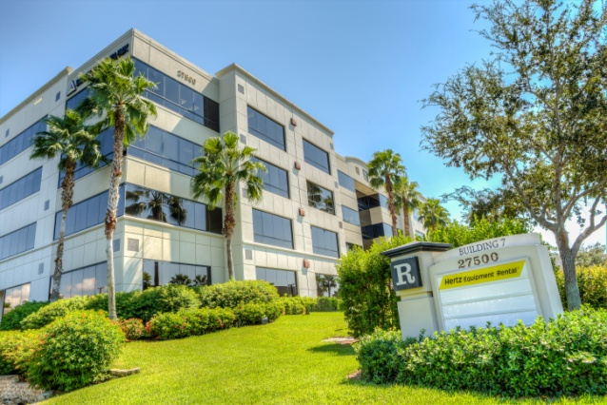

**Shaw Development**

