**Port Boca Grande Lighhouse and Museum**

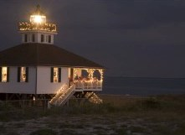

**Cayo Costa**

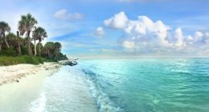

**Cabbage Key Inn and Restaurant**

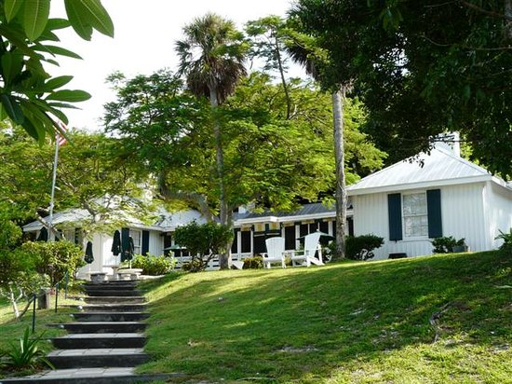

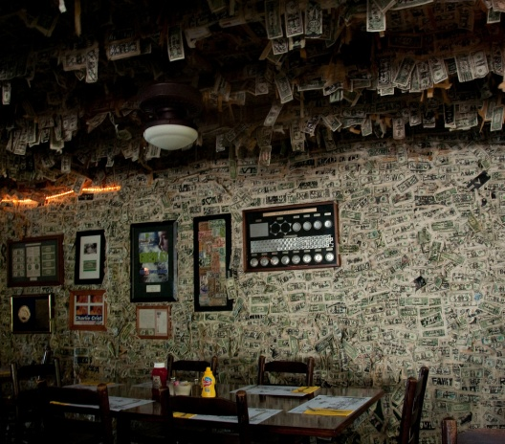

**South Seas Island Resort on Captiva Island**

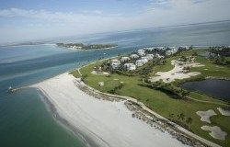

**Tween Waters Inn Island Resort & Spa on Captiva Island**

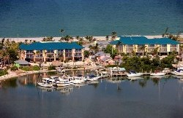

**Sanibel Lighthouse**

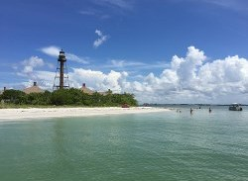

**Roseate Spoonbills at J.N. "Ding" Darling National Wildlife Refuge**

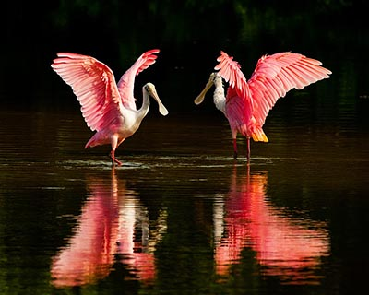

**Matlacha Art Community**

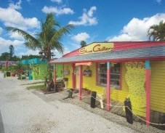

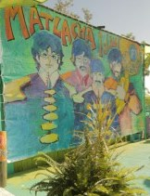

**Fort Myers Beach**

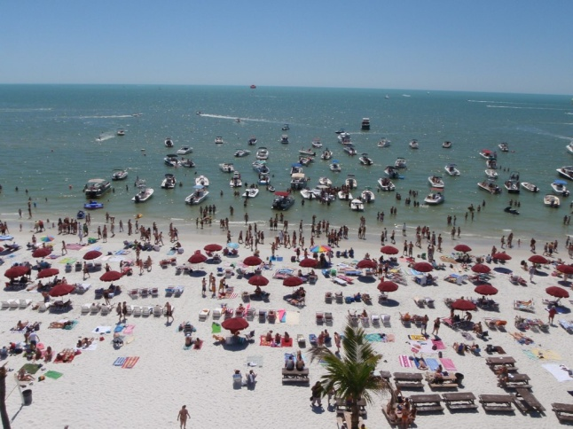

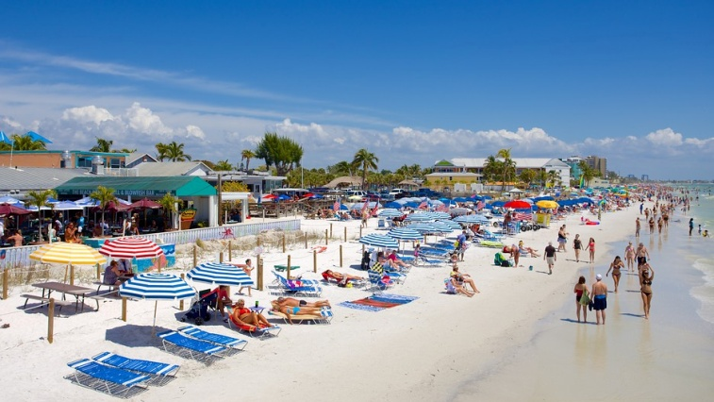

**Fort Myers Beach Times Square**

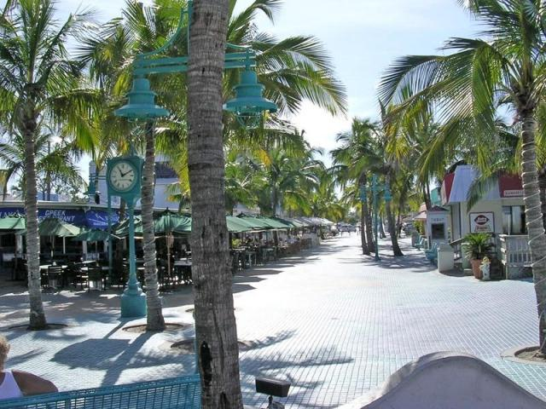

**Fort Myers Beach Shrimp Boats**

